Links to Jill Clark’s presentation “Marketing with or without a Pandemic.”
Below are the Illustrators for my first children’s poetry book Loose Balloons and second book Where Do Balloons Land? Loose Balloons Amazon If you purchase a book, please leave a review, and send me the link to your book so I can purchase and do likewise. Email: Jillclark2write@gmail.com website:
www.jillswriterscafe.com
- Brandy Winston was the illustrator for Loose Balloons: She also contributed to the second book, Where Do Balloons Land? released in October of 2021.
Brandy designed the tee shirt for my first book:
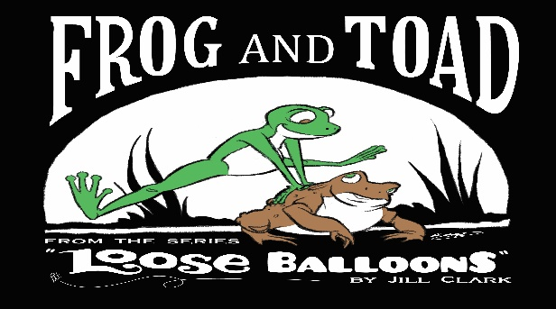
Brandy Winston’s Website is: https://bwillustration.artstation.com/
Brandy’s Bio
"Brandy Winston is a freelance illustrator with over five years’ experience in the Children’s Book publishing industry. She graduated in 2013 with a BFA from the Cleveland Institute of Art and has since worked to design and illustrate books for both traditional and self publishers. When not working, she enjoys playing video games with her husband and doting on their adopted dog, Luna."
***Vivian Saad is the primary illustrator to my second book:
Vivian’s Bio
- Vivian Saad illustrates children's and young adult books. She has a Bachelor's Degree in Graphic Design from the University Belas Artes of São Paulo, and currently lives in Brazil. She has illustrated more than forty books and has participated in exhibitions and catalogs in countries such as Argentina and Canada. Jill Clark's middle grade poetry book Where do Balloons Land? is Ms. Saad's illustrating-and-designing debut for a book in a foreign language. Vivian's illustrations capture the emotions and experiences that bond us as humans. Vivian formats and designs for book-publishing houses like Taylor and Seale Publishing in Daytona Beach, Florida.

To contact Vivian and view her work visit: http://www.viviansaadilustras.com

Trenton Bennett recorded and designed my audio book for Loose Balloons and also for audio promotional material for my second book. He is reliable, fast, flexible and his voices are fun to listen to. www.trentonbennett.com . He is an audio recorder of your work, but does not market your work, but he will recommend those who will.

Speaking of Marketers, here are two that are much more reasonably priced and that I find effective and trustworthy:
- Theodocia McLean from Book Marketing Global Network. Again, very, very reasonably priced and her network is all you need if you do not have a website or author’s page. She is thorough and runs all kinds of contests so you have a variety of opportunities and ways to display your work: Book Marketing Global Networking

Freshgroup.com is a trustable Indie publisher who has been in business for over 25 years and I highly recommend. They have all sorts of creative ways to market your book or writing. I first published with them because I had a short story place in a contest that they were running. They created an author’s page for me from that, and they add whatever new writing or books that I have:
Podcasts – Fresh Ink Group. Mind you, I have never hired them, they did this just because I won a contest with them. But their publishing prices, too, are very reasonable.

*For crochet dolls, action figures, toys, etc. to align with your book or promotional material, I recommend Neda’s Treasures: She will customize anything your imagination can conjure:
Neda's Customizing for your characters or promos

If you do business with any of them, please let them know that I sent you.
Thank you! Jill Clark

