Lesson Plan “Wonderfully Whale” Find-the- Rhyme Game
Language Arts Florida Standards 2018-2019
Demonstrate understanding of spoken words, syllables, and sounds.
LAFS.K.RF.2.2a Recognize and produce rhyming words
Language Component:
Grade: Kindergarten
Activity Time: 40-45 min.
Lesson: Find letter combinations in words whose end sounds sound the same
(Extra Activity If Time Permits): Find words whose sounds and spellings match

Depending on the overall ability of the class, this lesson could also be taught in K-1.

Content Objective: Three-Part Rhyming-Recognition Activity: Student will identify the sounds of letters and letter combinations that sound the same.
Students will listen to and identify end letter/sounds that are the same.
Lesson Purpose:
1) The purpose of this activity is to teach the definition of the literary term rhyme.
2) The student will identify whole-word repeat sounds and spellings and distinguish those repetition-word sounds and pronunciations (identical words) from end word-letter combinations that sound the same but may be spelled differently.
Key Vocabulary: bird, whale, mammal, camel, sea, chick
Concept Vocabulary: Rhyme: The repetition of the same end sound or sounds.
Materials:
Pencils and crayons
One 8x10 blank sheet of paper for each student
One copy of the poem “Wonderfully Whale” for each student
*Activity can be broken up into 3 segments depending on time.
Time: Total Time: 40-45 minutes
1st Part: P e-Activity Instruction, Coloring, Sharing, Syllable Count
- Vocabulary: Assess Prior Knowledge
- Have the six vocabulary words written on the whiteboard or projected via Power Point: Read each word aloud to the students. Circle the words bird, whale, mammal, camel, sea, chick on the board as you read each word. On their blank sheet of 8x10 paper, have the students select one of the words from the six that they would like to draw a picture of. Once they are finished drawing a picture of one of the vocabulary words, the teacher slowly calls out each vocabulary word. Any student who has drawn a representation of that announced vocabulary word may hold up (voluntarily) their drawing and show their picture to the class.
- Tell the students you are going to call out each word on the board again, but this time as you pronounce each vocabulary word, ask the students together as a class (along with the teacher) to count the number of syllables in the vocabulary word using their fingers to count. For example, as the teacher pronounces the word whale, one finger is held up.
2nd Part: Assess prior poetry knowledge: Explain purpose, & circle end-rhyme sounds
- Hand out the written poem “Wonderfully Whale” to each student.
Define the word rhyme for the students. Ask the class if they see any words in the poem that have the same letters/sounds or combinations at the end of a word. If some of the students circle whole words that are identical in spelling and sound to other whole words, talk about why this is not rhyme—because all the sounds/letters in the words are identical. Remind them of the definition of the word rhyme. [The repetition of the same end sound or sounds.]
- Ask the students what they think a poem is. How is a poem different from a story? Do they have a favorite poem? Do they know the title or author’s name of a poem that they like?
- Have the students look at the poem on their own handout sheet and ask them how the form or structure of this poem’s printed letters and layout look different from their other story books’ print layout?
[Teacher may hold up an open story book and slowly rotate it so each of the children can see the storybook layout, and then compare that print format to the poem that they have at their desk.]. Discuss some of their answers. They may notice the printed lines are spaced differently. You could tell them a group of lines that belong together in a poem is called a stanza.
- Tell the students by listening to and identifying poetry whose words’ end letters sound the same, they will be better able to hear the difference between whole words that repeat each other in sound and spelling, from rhymed end-letter combinations that sound the same.
- Before reading the poem aloud, ask the class to listen for end-word letter combinations that sound alike. Remind them that the exact repeat of the same whole word is not a rhyme. This is called a word repetition.
- Tell the students you would like for them to circle any exact sound of letter groups that occur at the end of a word, as you read the poem aloud. Remind the students that if a whole word is repeated in the poem, or has the same sound, then do not circle those sounds because they are not a rhymed match.
- Practice Sample: Tell the students you will practice first together as a class. Ask the students to raise their hands if they can find the first two words that rhyme in the poem [Answer bird and heard in the first line]. Tell them to circle the rhyme or matching end sounds/letters on their printed poem in front of them. Talk about their choices, making note of how the first example of rhymed words sounds musical and makes the poem more fun.
- Possible questions to extend this first rhyme example might include other words that rhyme with bird or heard. Possible answers from the class might include third, nerd, curd, word. [Curd may sound like too advanced of a vocabulary word, but if they remember the nursery rhyme where “Little Miss Muffet,” was eating her curds and whey, they may think of that rhyming word.]
3rd Part: Poem reading, students circle like-sounding end-letters/sounds
- Teacher reads the poem “Wonderfully Whale” aloud with inflection to the children. Have the students follow along as instructor reads looking at their own copy of the poem.
- Have the students circle any letters or combination of letters that occur at the end of a word that sounds like another end-series of letter combinations/sounds.
- They may want you to read the poem a second time if they did not get a chance to circle all of the letter combinations that sound the same at the end of the word. Read the poem more slowly this time, and let them know they may continue circling after the poem is read.
[Provide adequate time for the students to figure out and circle the words and letter combinations that sound alike.]
- When they are finished circling their word parts, either go over the circled answers with them as a class, sounding out the end sounds that rhyme together, or have the students hand in their work. If you have them hand in their work, when you hand back their papers, then go over the answers with the class orally, sounding out each rhymed match, and, if possible, posting where they can see the answer key clearly.
***Difficulty: It will be easier for the students to identify whole word units that are pronounced the same and spelled alike (like bird); they most likely will have a more difficult time identifying end sounds like “ird” in the word bird, and “eard” in the word heard, that sound the same. The students might miss circling those sound units because the two words bird and heard are spelled differently and have different initial letter sounds.
(If time permits, you could also have the students select words that are repeat words, and how many times does the vocabulary word/s appear in the poem? For example, the word whale appears five times.

Poem copy below

WONDERFULLY WHALE
“A bird is a bird,” have you heard?
But a whale’s a mammal, you see—
like a milk-drinking camel,
a whale is a mammal,
a mammal who lives in the sea.

Would Mrs. Whale like
her mammal babe more
if her babe were a chick
and pecked from a floor?

No,
Mrs. Whale knows—
(believe me she knows!)
her baby is best
swimming beside her,
not needing a nest.

ANSWER KEY
Rhyming words
bird and heard line 1
mammal and camel lines 3 & 4
more and floor lines 10 & 12

End-rhyme sounds/letter combinations circled below as well as repeat whole words.
WONDERFULLY WHALE
“A bird is a bird,” have you heard? (“eard” is the same sound as “ird” in the word bird.
But a whale’s a mammal, you see—
like a milk-drinking camel “amel” from camel matches the sound of “ammal” from mammal
a whale is a mammal, is a is a blended sound but two different words, & matches the is a in the
first line of the poem
a mammal who lives in the sea.

Would Mrs. Whale like
her mammal babe more--“ore” is the same sound in the word more as “oor” in floor below
if her babe were a chick
and pecked from a floor?--“oor” in the word floor is the same sound as in the word more above

No,
Mrs. Whale knows—
(believe me she knows!)
her baby is best
swimming beside her,
not needing a nest.

How many times do the vocabulary words appear in the poem?
Whale 5 times
bird 2 times
mammal 4 times
camel 1 time
chick- 1 time

Answer: 42 identical sound words or letter-combination sounds
Answer Key on Website
Kindergarten High Frequency Word List
Level I Level 2 Level 3 Level 4 Level 5
a me to yes big
I go in cat for
is at on dog he
the you like up she
mom we my with this
dad it by said look
can no love play went
see am do was
a

Extra: If a discussion occurs about the word curd, below is the word defined: (cottage cheese)

Noun:

Often used as a plural: curds.
curd: A substance consisting mainly of casein and the like, obtained from milk by coagulation, and used as food or made into cheese.
Any substance resembling this.
Also called “curd cheese.” Chiefly Northeastern and Southern U.S. cottage cheese.
Also, the edible flower heads of cauliflower, broccoli, and similar plants.

Verb (used with or without object)
to turn into curd; coagulate; congeal.

“Curd.” Dictionary.com. 2019. https://www.dictionary.com/browse/curd. Accessed
1 April 2019.

O

National Geographic Whale mammals: ORCA and calf
(Did you see the Bird resting on an iceberg in the background in the picture above?). No? Let’s go back and look.

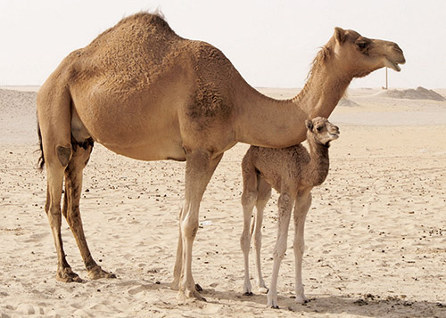

Camel mammals in the desert

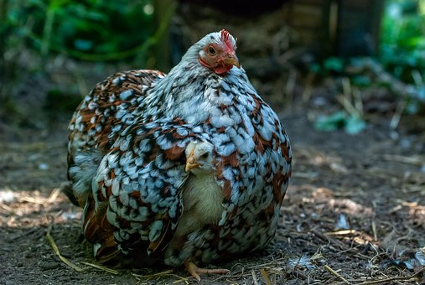
Bird Class Aves
Mother hen (bird) with her chick

Photos not to be used in print material, copy, or for purposes of sale.

